PROGRAM FOLDER
PROGRAM ID: TSLTradeFinance
Version 20240321

TATA STEEL

Table of Contents

Contents
1. Change History 2
2. Customer Requirement 2
3. Technology Used 3
4. Tables and the Operations on them 3
5. Interface with other systems, modules or programs 3
6. Product Requirements 3
7. Process Flow 6
8. Number of users who will use the program 6
9. Security privileges of the program 6

Program Specification
Program ID : TradeFinanceMT798Microservice
Program Description : This program generate and process MT798 messages. This program is also runs on background.

1. Change History
Version | CMR No | Date | Author | Description
V0.0.1 |  | 11.02.2022 | Jamil | 1. lc-generator going live  2. swift-notfication going live
V0.1.2 |  | 14.04.2022 | Jamil | 1. lc-receiver is going live  2. [lc-generator] value mapping is modified.  3. Error email sending on failure of any task to a pre-defined list of email addresses.
V0.2.02 |  | 27.06.2022 | Jamil | 1. MT719 support is added  2. PDF generator added that will go along with MT719
V0.3.012 |  | 11.11.2022 | Jamil | 1. MT772 support added
V0.3.020 |  | 22.02.2023 | Jamil | 1. SBI Specific changes has been included for field MT770 F29P
V0.3.023 |  | 08.06.2023 | Jamil | 1. Support for SBI Specific changes in MT719 flow.  2. SBI Specific changes done on field T31C, T44C, T31D, T32B, T33B, T29P  4. REPALL Logic added for field T45B, T46B, T47B
V0.3.129 |  | 20.09.2023 | Jamil | 1. Emidra support added  2. Non-Swift flow using Emudra and Email  3. Queue feature for failed transactions
0.4.001 |  |  | Jamil | 1. LC Acceptance Flow  2. Bug Fixes
20240321 |  | 21.03.2024 | Jamil | - Improved Queue feature for failed transactions

2. Customer Requirement
It is a part of TSLTradeFinance project which deals with generating and processing MT798 messages. The generated MT798 messages are sent to the bank through SWIFT and process MT798 messages issued by the bank received through swift.

3. Technology Used
GoLang, fabric-go-sdk

4. Functions

5. Interface with other systems, modules or programs
TradeFinanceRESTServer

6. Product Requirements
It is service that controls the execution of 3 micro-services. Please refer to the below table
Sl No | Microservice Name | Description
1 | lc-generator | This service generates set of MT798 for LC Issuance.
2 | swift-notification | This service reads the NetAck and DeliverNotif files and update the status of the transaction
3 | lc-receiver | This service process the MT798 messages from SWIFT and process it. When all the parts of MT798 message are received, the status of the corresponding message is updated.

7. Process Flow
7.1 Process Flow for swift-notificaiton
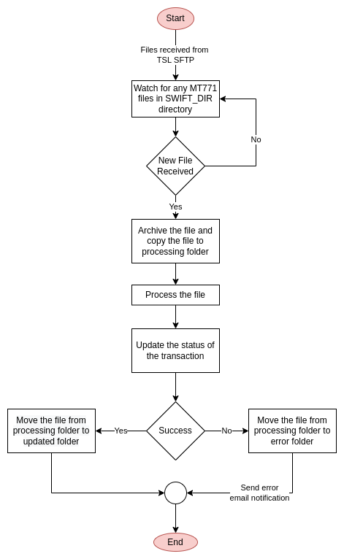
7.2 Process Flow for lc-generator service
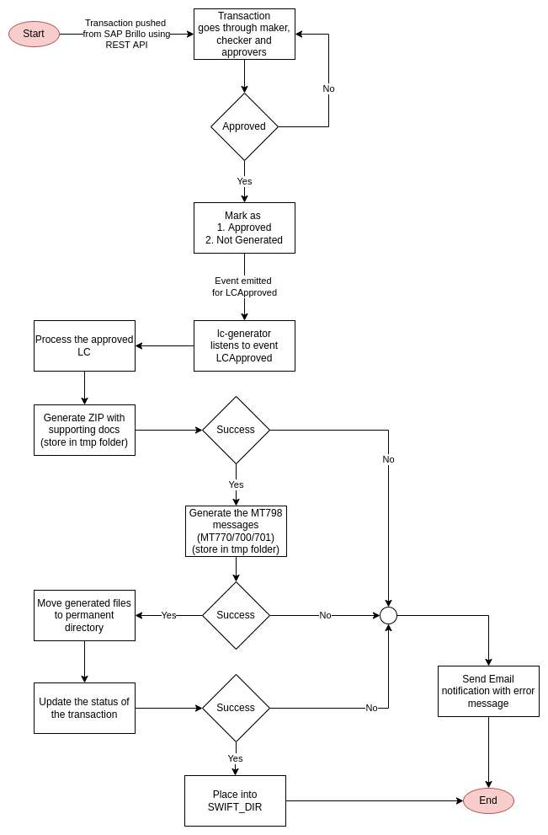

7.3 Process Flow for lc-receiver service
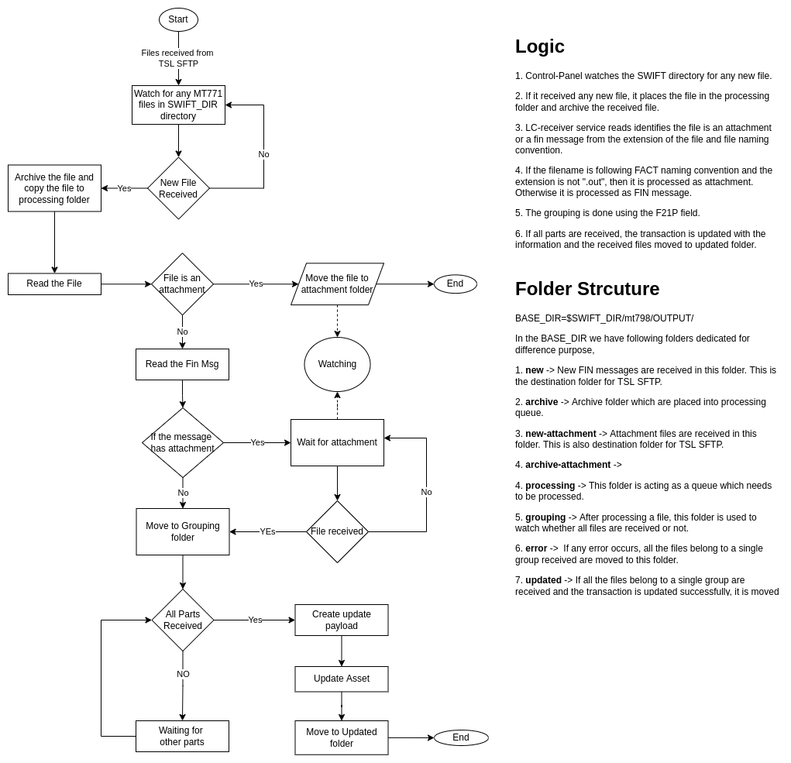

8. Number of users who will use the program
This program runs on background and part of the application. No direct interaction is available.

9. Security privileges of the program
This program is not exposed to external world. It only communicates with hyperledger network which is TLS protected

